> library(aimsir17)
> library(dplyr)

Attaching package: ‘dplyr’

The following objects are masked from ‘package:stats’:

filter, lag

The following objects are masked from ‘package:base’:

intersect, setdiff, setequal, union

> library(ggplot2)
> summary(observations)
station year month day
Length:219000 Min. :2017 Min. : 1.000 Min. : 1.00
Class :character 1st Qu.:2017 1st Qu.: 4.000 1st Qu.: 8.00
Mode :character Median :2017 Median : 7.000 Median :16.00
Mean :2017 Mean : 6.526 Mean :15.72
3rd Qu.:2017 3rd Qu.:10.000 3rd Qu.:23.00
Max. :2017 Max. :12.000 Max. :31.00

hour date rain
Min. : 0.00 Min. :2017-01-01 00:00:00 Min. : 0.0000
1st Qu.: 5.75 1st Qu.:2017-04-02 05:45:00 1st Qu.: 0.0000
Median :11.50 Median :2017-07-02 11:30:00 Median : 0.0000
Mean :11.50 Mean :2017-07-02 11:30:00 Mean : 0.1227
3rd Qu.:17.25 3rd Qu.:2017-10-01 17:15:00 3rd Qu.: 0.0000
Max. :23.00 Max. :2017-12-31 23:00:00 Max. :16.6000
NA's :157
temp rhum msl wdsp
Min. :-6.2 Min. : 20.00 Min. : 962.2 Min. : 0.000
1st Qu.: 7.5 1st Qu.: 77.00 1st Qu.:1007.5 1st Qu.: 5.000
Median :10.6 Median : 86.00 Median :1015.6 Median : 8.000
Mean :10.3 Mean : 83.65 Mean :1014.4 Mean : 9.426
3rd Qu.:13.4 3rd Qu.: 93.00 3rd Qu.:1022.3 3rd Qu.:12.000
Max. :28.3 Max. :100.00 Max. :1039.1 Max. :59.000
NA's :166 NA's :144 NA's :182 NA's :17547
wddir
Min. : 0.0
1st Qu.:170.0
Median :220.0
Mean :213.3
3rd Qu.:270.0
Max. :360.0
NA's :17548
> storm <- observations %>%
+ filter(day %in% 15:17, month==10) %>%
+ filter(station %in% c("MACE HEAD", "ROCHES POINT", "DUBLIN AIRPORT"))
> ggplot(storm,aes(x=date,y=wdsp,colour=station))+
+ geom_point()+geom_line()

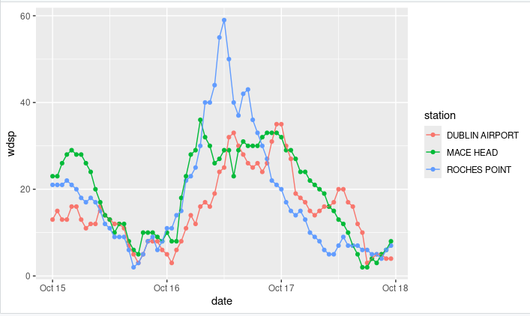

> ggplot(storm,aes(x=date,y=msl,colour=station))+
+ geom_point()+geom_line()

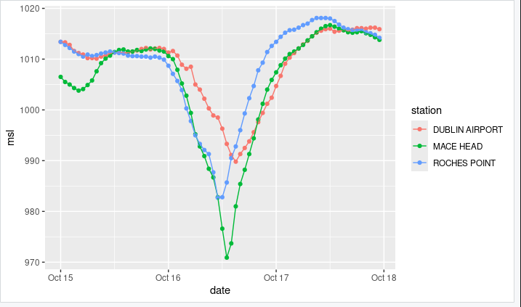

> ggplot(storm,aes(x=date,y=rain,colour=station))+
+ geom_point()+geom_line()
